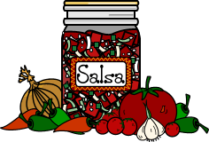

**Ingredients: (Makes ten 8oz jars or five pint jars)**

* 7 cups chopped tomatoes
* 2 cups chopped onion
* 1 cup chopped green bell pepper
* 3 cloves garlic, finely chopped
* 1 can tomato paste
* ¾ cup white vinegar
* ½ cup chopped cilantro
* ½ tsp ground cumin

**Directions:**

1. In a large kettle combine tomatoes, onions, green peppers, garlic, tomato paste, vinegar, cilantro and cumin. Bring to a boil over medium-high heat, stirring constantly. Reduce heat and boil gently, stirring frequently, until thickened, about 30 minutes.
2. Meanwhile, prepare jars and lids.
3. Ladle hot salsa into jars, leaving ½ inch headspace. Remove air bubbles and adjust headspace, if necessary, by adding hot salsa. Wipe rim. Center lid on jar. Screw band down until resistance is met, then increase to fingertip-tight.
4. Place jars in basket. The canning plant staff will process pint jars for 20 minutes.